No. | Answer
a 2-fluoropropene
b propane
c 3-methylbutanoic acid
d 2-methylpropan-1-ol
e trichlorofluoromethane
 | 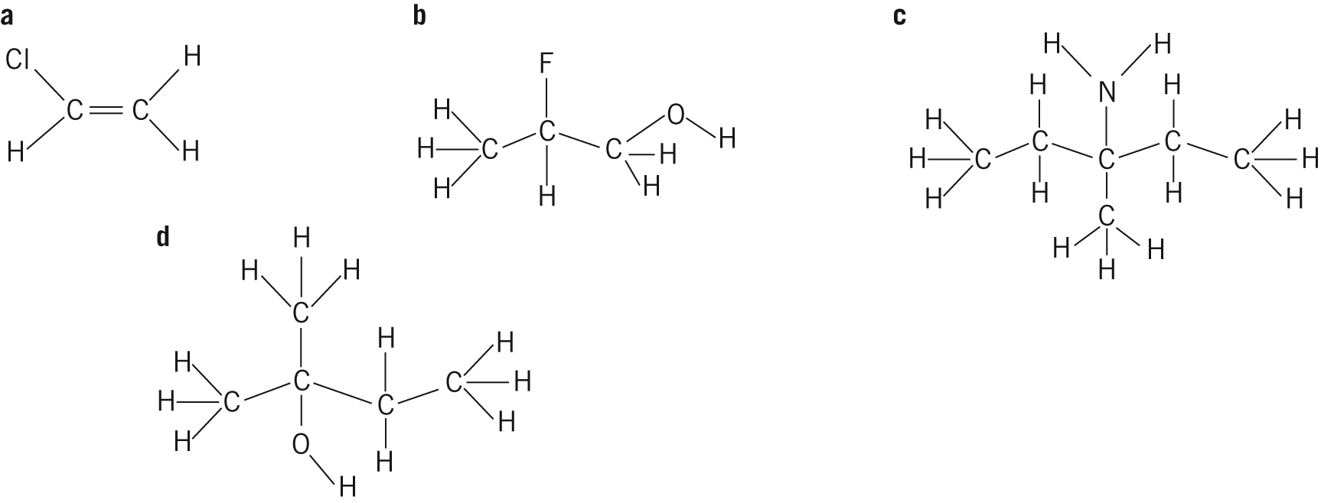
a C_{n}H_{2n + 2}
b C_{n}H_{2n}
c C_{n}H_{2n + 1}OH
d C_{n – 1}H_{2n – 1}COOH
 | a | 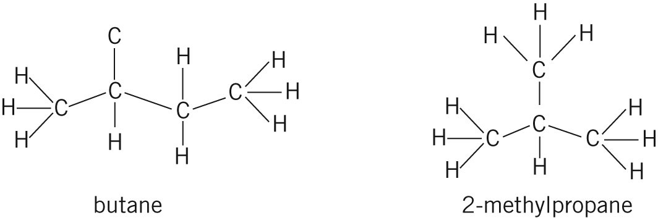
 | b Butane has the higher boiling point, because the more linear molecule means that molecules pack well together, giving greater contact between adjacent molecules and hence stronger dispersion forces. Stronger forces mean a higher boiling point. The branched molecules of 2-methylpropane do not pack together very well.
 | Pent-1-ene (cis and trans) pent-2-ene, 2-methylbut-1-ene, 2-methylbut-2-ene, 3-methylbut-1-ene
 | 